**CPS 633 - Lab 2 Report**

Section 4 Group 10

**Task 1**:

First we change the default incoming in the default policy file /etc/default/ufw from “DROP” to “ACCEPT” in order to allow all traffic to pass through the firewall by default.

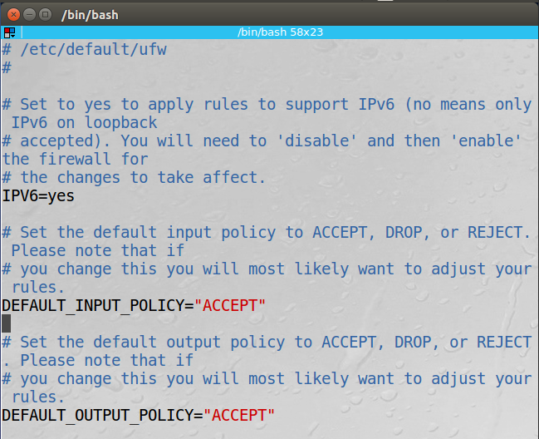

To begin the task we have to enable ufw using the command sudo ufw enable then we implement the rules as follows.

To deny telnet out we simply do:

sudo ufw deny out telnet

To deny telnet coming in we do:

sudo ufw deny telnet

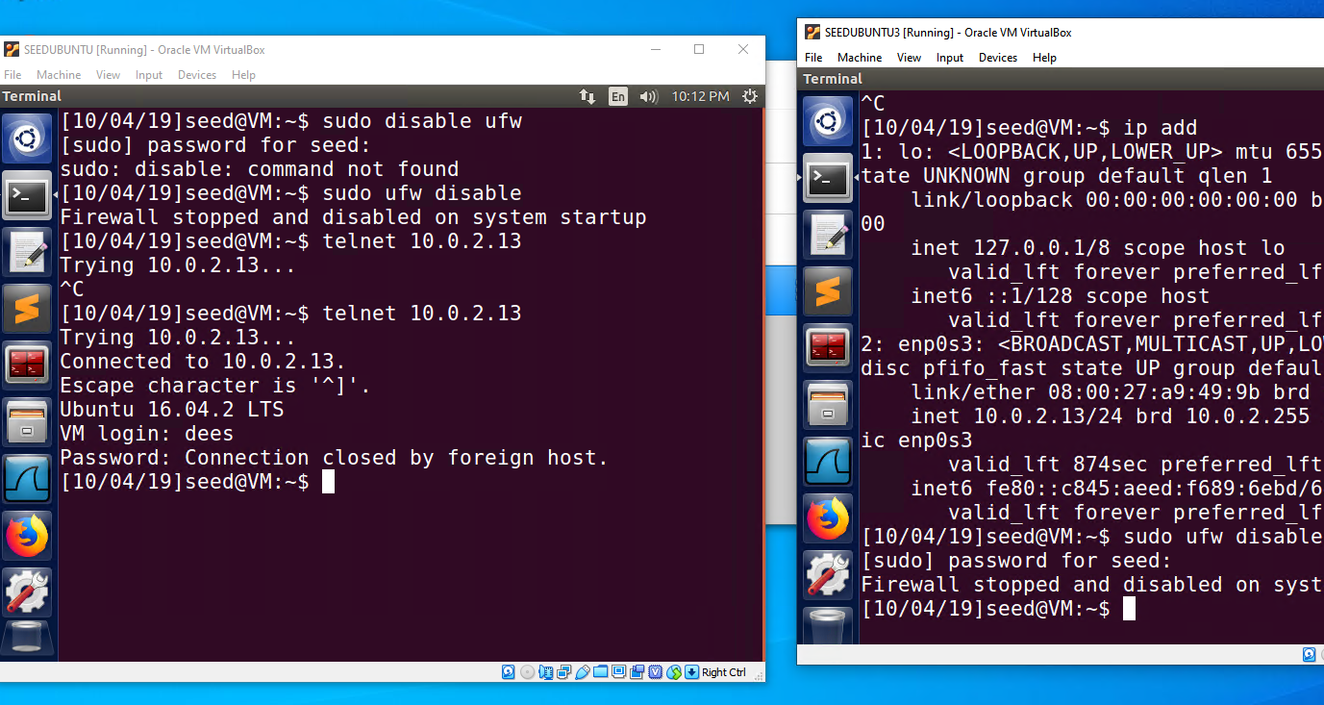

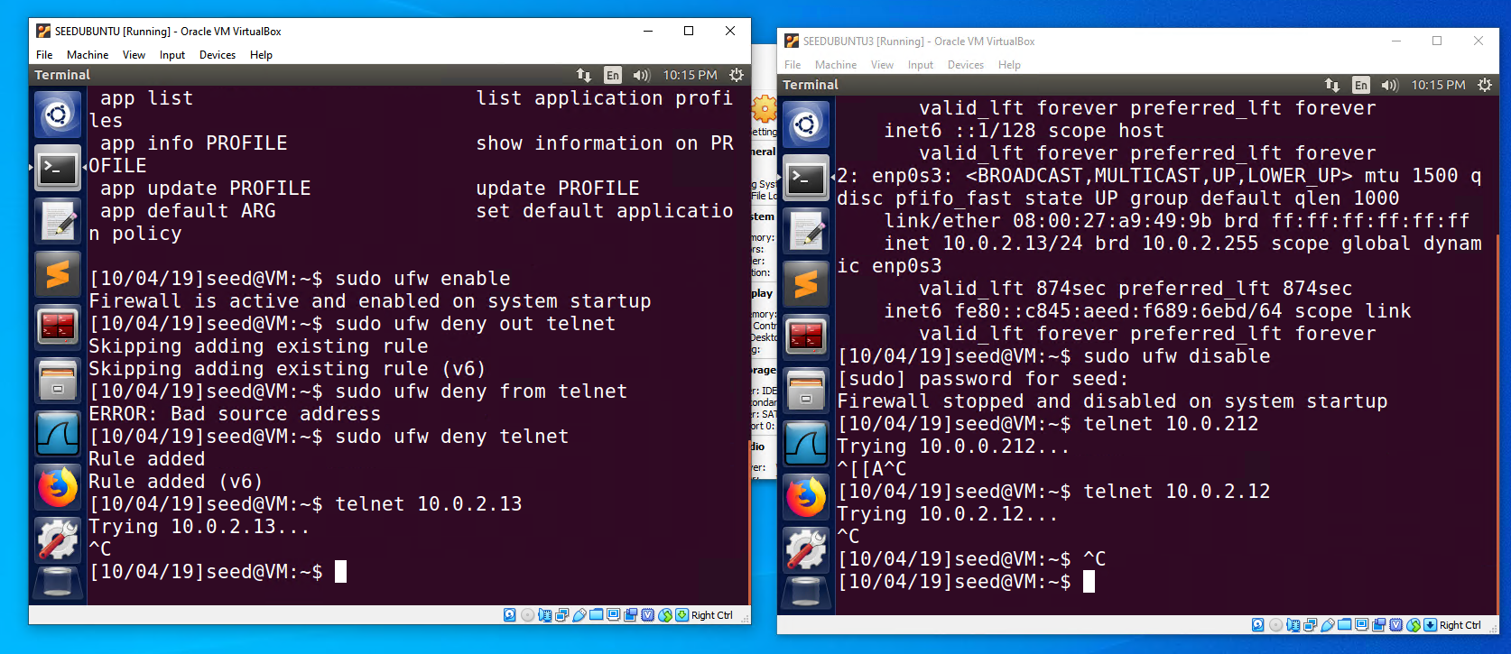

When the first VM tried to telnet the second it was not able to connect:

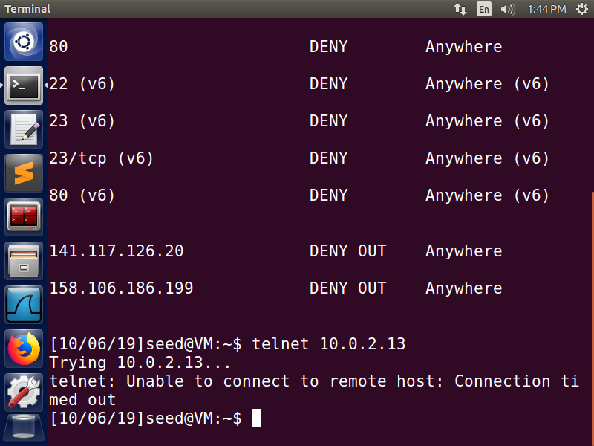

When the second VM tried to telnet the first it also was not able to do so:

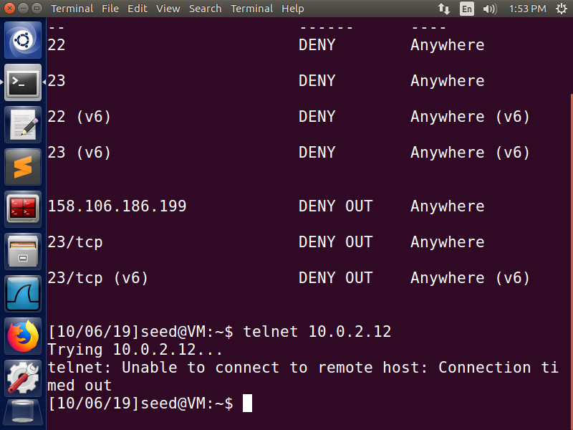

To deny access to a webpage (capfriendly.com) we do:

Nslookup capfriendly.com \\ get ip address of capfriendly.com

sudo ufw deny out to 158.106.186.199

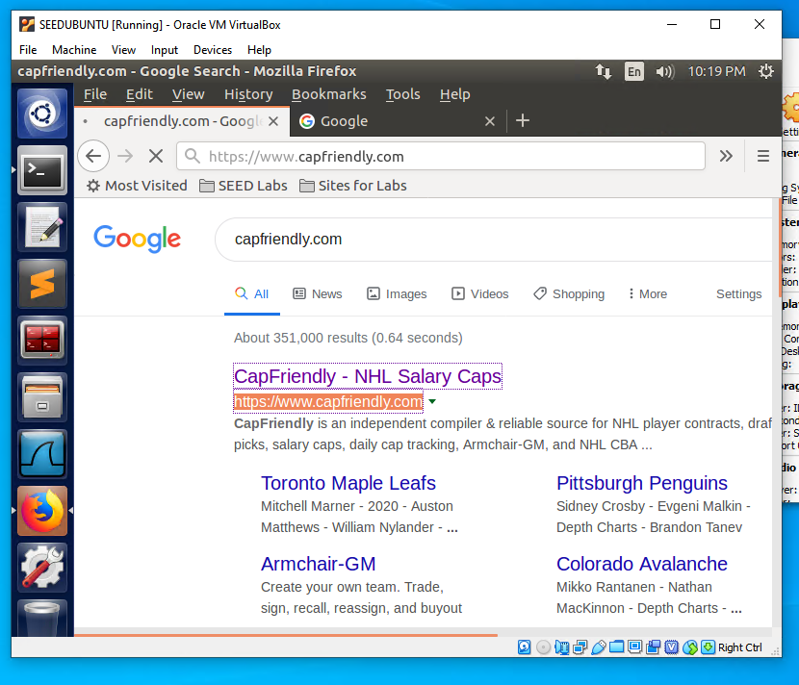

When we try to telnet the IP address of the site, we are not able to connect because the ufw prevents outgoing telnet to 158.106.186.199:

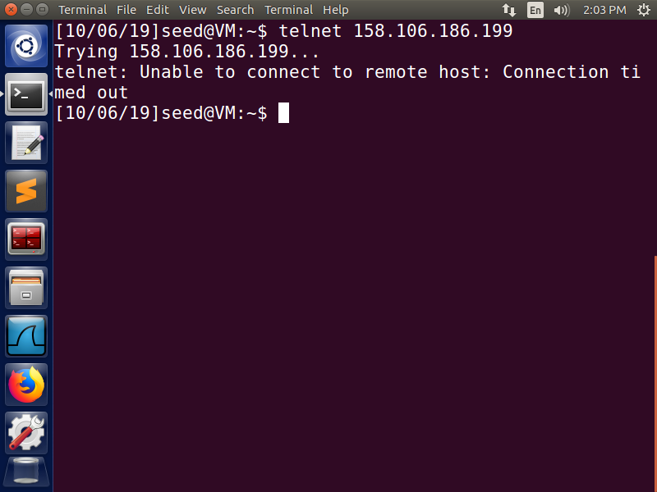

**Task 2**:

Full source code available on the last page of the report.

Rule 1:

Drop all packets incoming from VM2, the highlighted piece of code defines the rule to drop all packets coming from VM2. This rule is removed after to test the other rules individually.

unsigned int hook_func(void *priv, struct sk_buff *skb, const struct nf_hook_state *state)

{

sock_buff = skb;

ip_header = (struct iphdr *)skb_network_header(sock_buff);

if(!sock_buff)

{

return NF_ACCEPT;

}

printk(KERN_INFO "\n incoming packet..\n");

//all packets from VM2

if(((ip_header->saddr & 0xff000000) >> 24) == 13)

{

printk(KERN_INFO "\n dropping all packets coming ");

return NF_DROP;

}

return NF_ACCEPT;

}

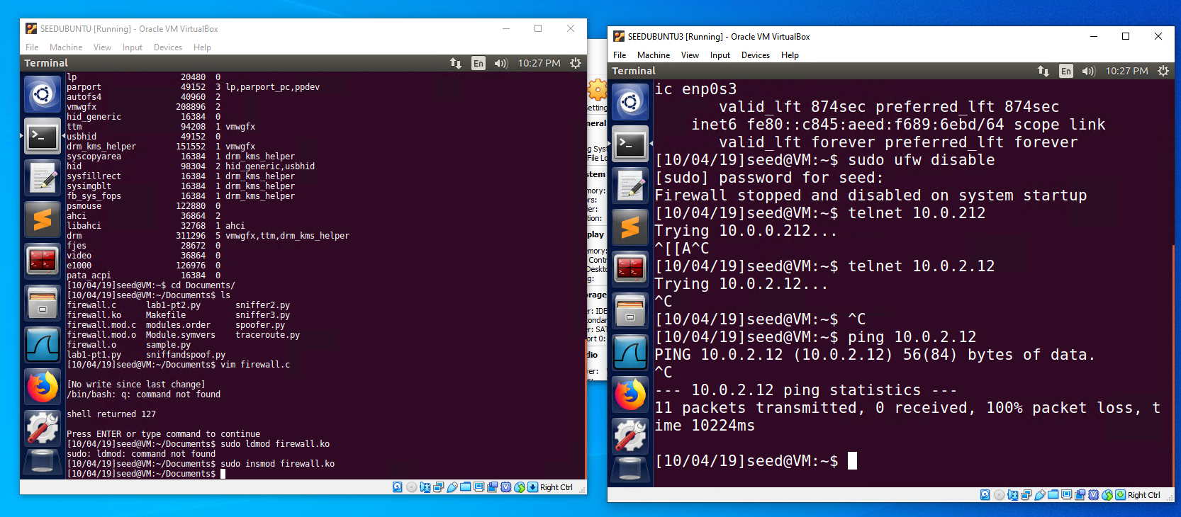

Rule 2:

Drop all packets from incoming ftp requests, these ftp requests are sent as TCP packets with the destination port 21. So we drop all TCP packets with destination port 21.

if(ip_header->protocol == 6) //tcp packets

{

tcp_header = (struct tcphdr *)skb_transport_header(sock_buff);

src_port = (unsigned int) ntohs(tcp_header->source);

dst_port = (unsigned int) ntohs(tcp_header->dest);

if(dst_port == 21)

{

printk(KERN_INFO "tcp telnet packet incoming\n");

printk(KERN_INFO "dropping tcp telnet request packet\n");

return NF_DROP;

}

}

}

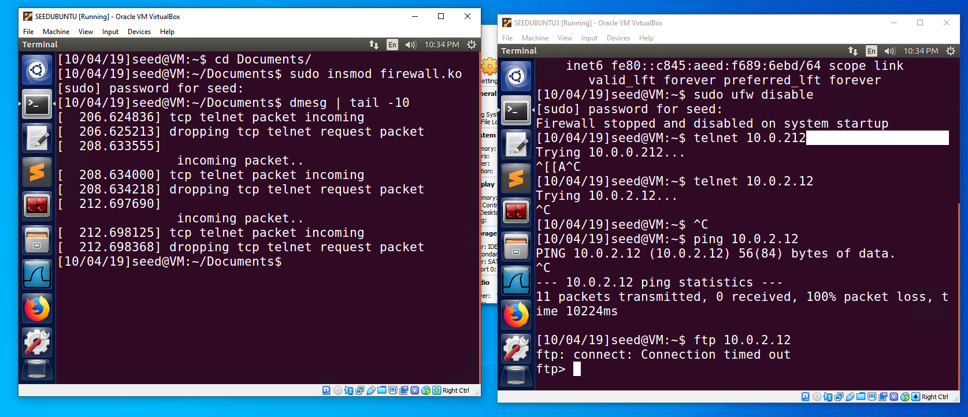

Rule 3:

Drop all packets OUTGOING to VM2, that means we make a new hook function that takes a look at all outgoing packets and examines them. This new hook function (hook_func_out) will handle the last 3 rules for our firewall. Again this rule is removed after here to test the last 2 rules.

unsigned int hook_func_out(void *priv, struct sk_buff *skb, const struct nf_hook_state *state)

{

sock_buff = skb;

ip_header = (struct iphdr *)skb_network_header(sock_buff);

if(!sock_buff)

{

return NF_ACCEPT;

}

printk(KERN_INFO "\n outgoing packet..\n");

//outgoing to VM2

if(((ip_header->daddr & 0xff000000) >> 24) == 13)

{

printk(KERN_INFO "\n dropping all packets going to vm2 ");

return NF_DROP;

}

return NF_ACCEPT;

}

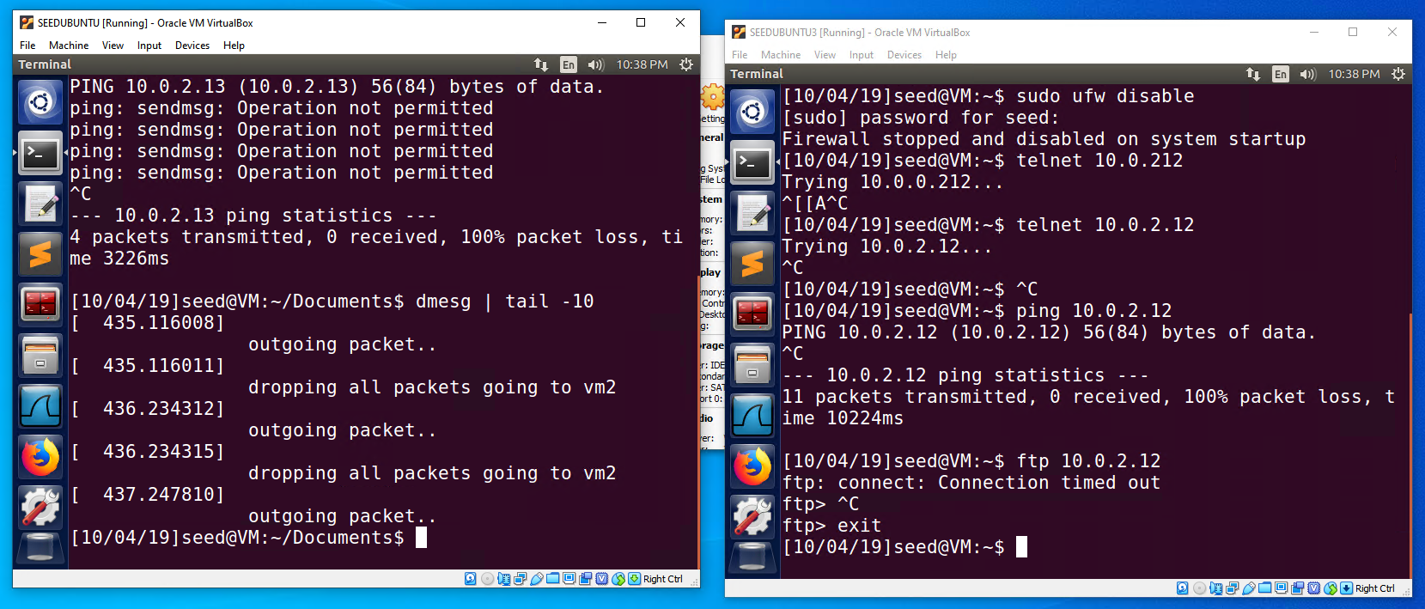

Rule 4:

Drops all OUTGOING packets to capfriendly.com, thus now allowing the user to access the webpage with this firewall enabled. This is done through dropping all packets with the destination IP of the webpages server, this webpage only seems to have 1 server IP so it makes it easy for this firewall to block.

//outgoing to capfriendly.com

if((ip_header->daddr & 0x000000ff) == 158 && ((ip_header->daddr & 0x0000ff00) >> 8) == 106 && ((ip_header->daddr & 0x00ff0000) >> 16) == 186 && ((ip_header->daddr & 0xff000000) >> 24) == 199)

{

printk(KERN_INFO "\n requesting capfriendly.com");

printk(KERN_INFO "\n dropping packet\n");

return NF_DROP;

}

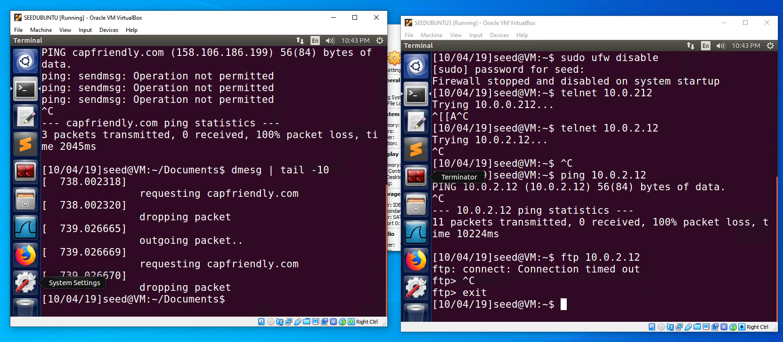

Rule 5:

Drops all packets OUTGOING for an ftp request, does not allow the user to ftp into any other user by dropping all the TCP packets with the destination port of 21.

//ftp packets outgoing

if(ip_header->protocol == 6) //tcp packets

{

tcp_header = (struct tcphdr *)skb_transport_header(sock_buff);

src_port = (unsigned int) ntohs(tcp_header->source);

dst_port = (unsigned int) ntohs(tcp_header->dest);

if(dst_port == 21)

{

printk(KERN_INFO "tcp telnet packet outgoing\n");

printk(KERN_INFO "dropping tcp telnet packet\n");

return NF_DROP;

}

}

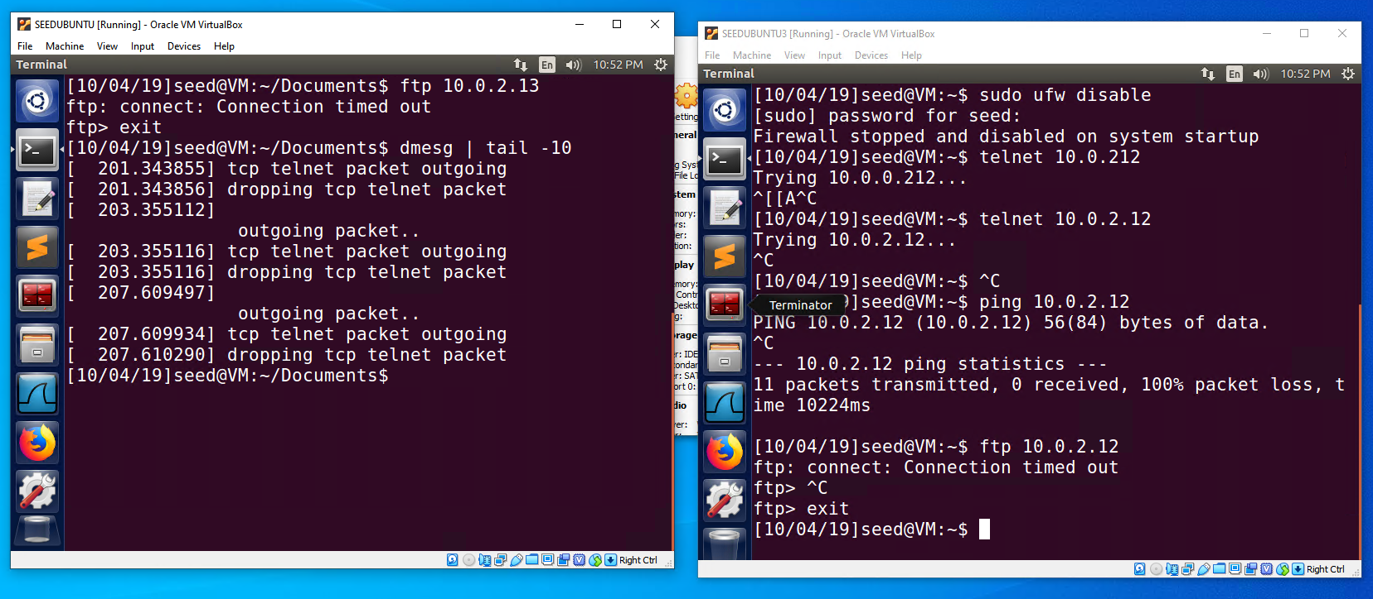

**Task 3**:

3.a:

To begin we deny all telnet out using ufw firewall, this rule is already set from Task 1 so we leave it. We also then block access to ryerson.ca using command sudo ufw deny out to 141.117.126.20

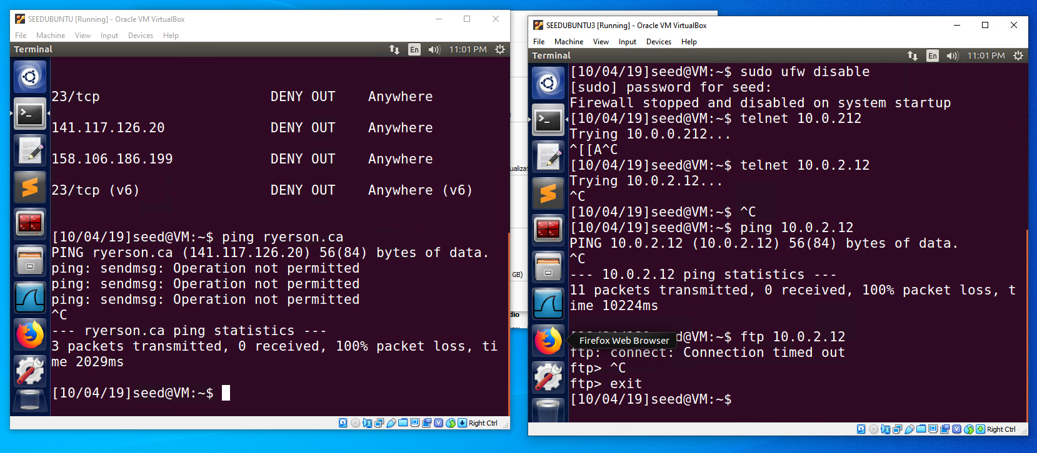

Next we create an SSH tunnel from VM1 to VM2 so that we can telnet into VM3, in this example we only have 2 VMs so we will set up the SSH tunnel between the 2 VMs. In this case we do not need to telnet into VM3 because once the SSH tunnel is set up we will have access to VM2 and there is no point in telneting into a VM we already have access to.

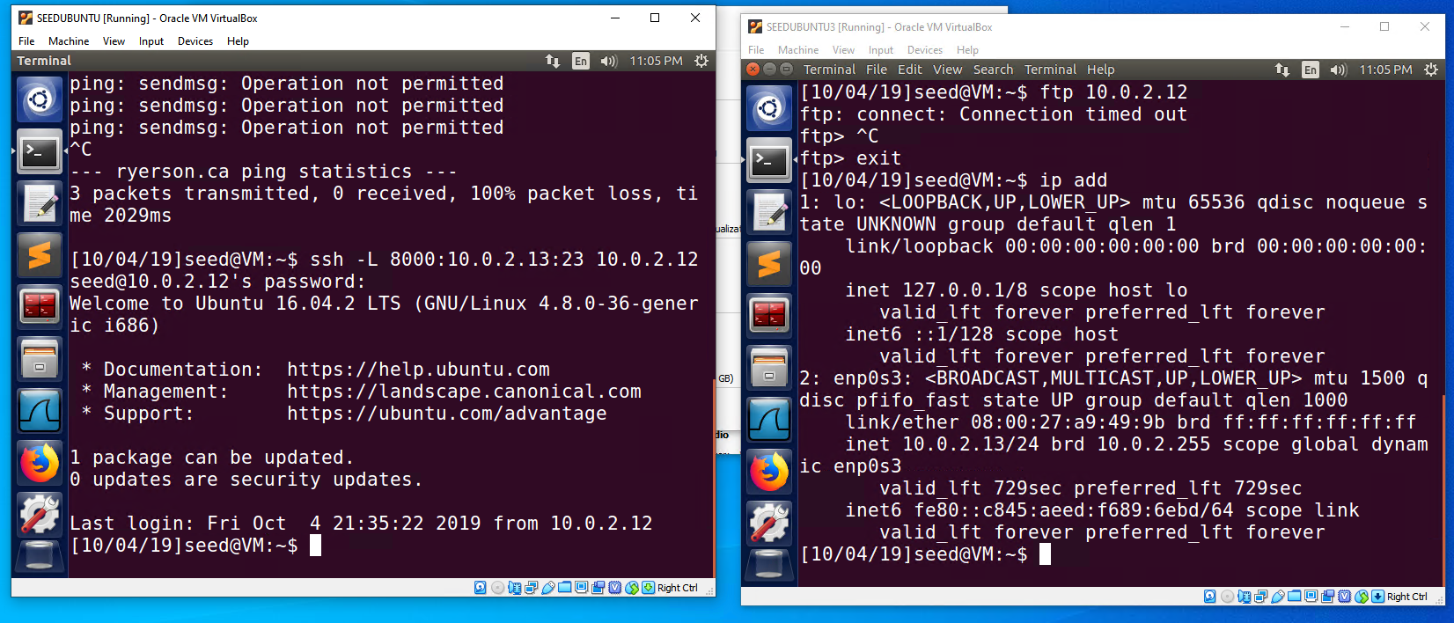

What is supposed to happen is every packet that comes from VM3 goes to VM2 and then passes through the SSH tunnel to VM1. Therefore VM1 gains access to VM2 and VM2 can telnet into VM3 to allow VM1 to gain access to VM3, then information is sent to VM2 from VM3 through telnet and then VM2 forwards that information to VM1 through the SSH tunnel.

3.b

1. After setting up the SSH tunnel to VM2 on port 9000 and configuring the proxy I was able to access ryerson.ca even though the destination IP is blocked on my firewall.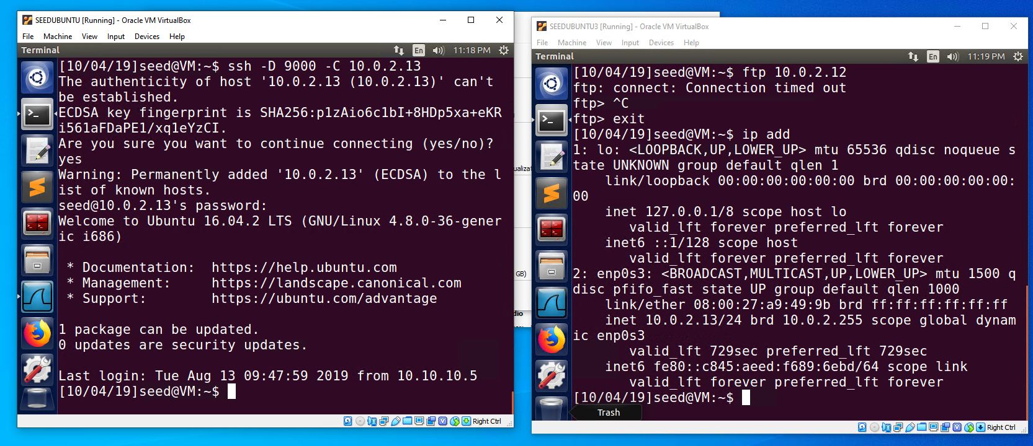
2. After breaking the SSH tunnel to VM2, VM1 can no longer access ryerson.ca as the port 9000 cannot connect since VM2 is shut down.
3. When VM2 is restarted it restores the SSH tunnel between VM1 and VM2 and the proxy is able to connect to port 9000 again, allowing access to ryerson.ca
4. When the packets are sent through the SSH they contain no information regarding ryerson.ca, so just ip information, TCP, SSH and with the port number 22. So because there is no information regarding ryerson.ca and port 22 is not blocked it is accepted by our firewall and allows us to access ryerson.ca

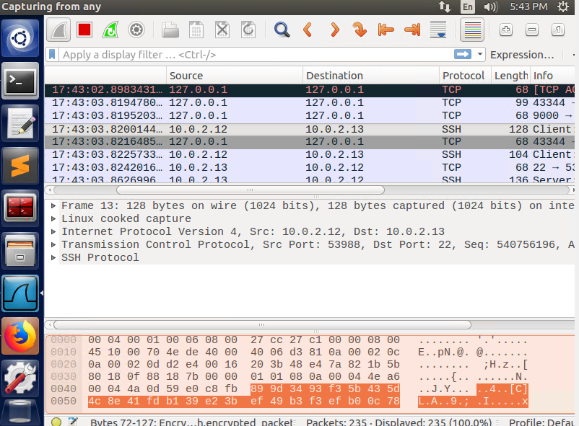

**Task 4**:

First we set up a reverse SSH tunnel on Machine A by running the command:

ssh -R 8001:localhost:22 10.0.2.12

This command initiates a remote ssh that begins to listen to any SSH request coming from Machine B port 8001 should be forwarded Machine A port 22 which is the SSH port.

Then on Machine B, we simply make an SSH request to port 8001 in order to gain access to Machine A and its internal web server:

ssh localhost -p 8001

We are then prompted for the password and once correctly inputted we gain access to Machine A.

Source Code for Task 2:

#include <linux/kernel.h>

#include <linux/module.h>

#include <linux/netfilter.h>

#include <linux/netfilter_ipv4.h>

#include <linux/skbuff.h>

#include <linux/tcp.h>

#include <linux/icmp.h>

#include <linux/ip.h>

static struct nf_hook_ops nfho_out;

static struct nf_hook_ops nfho;

struct sk_buff *sock_buff;

struct iphdr *ip_header;

struct tcphdr *tcp_header;

unsigned int src_port, dst_port;

unsigned int hook_func(void *priv, struct sk_buff *skb, const struct nf_hook_state *state)

{

sock_buff = skb;

ip_header = (struct iphdr *)skb_network_header(sock_buff);

if(!sock_buff)

{

return NF_ACCEPT;

}

printk(KERN_INFO "\n incoming packet..\n");

//all packets from VM2

if(((ip_header->saddr & 0xff000000) >> 24) == 13)

{

printk(KERN_INFO "\n dropping all packets coming ");

return NF_DROP;

}

//ftp packets incoming

if(ip_header->protocol == 6) //tcp packets

{

tcp_header = (struct tcphdr *)skb_transport_header(sock_buff);

src_port = (unsigned int) ntohs(tcp_header->source);

dst_port = (unsigned int) ntohs(tcp_header->dest);

if(dst_port == 21)

{

printk(KERN_INFO "tcp telnet packet incoming\n");

printk(KERN_INFO "dropping tcp telnet request packet\n");

return NF_DROP;

}

}

}

return NF_ACCEPT;

}

unsigned int hook_func_out(void *priv, struct sk_buff *skb, const struct nf_hook_state *state)

{

sock_buff = skb;

ip_header = (struct iphdr *)skb_network_header(sock_buff);

if(!sock_buff)

{

return NF_ACCEPT;

}

printk(KERN_INFO "\n outgoing packet..\n");

//outgoing to VM2

if(((ip_header->daddr & 0xff000000) >> 24) == 13)

{

printk(KERN_INFO "\n dropping all packets going to vm2 ");

return NF_DROP;

}

//outgoing to capfriendly.com

if((ip_header->daddr & 0x000000ff) == 158 && ((ip_header->daddr & 0x0000ff00) >> 8) == 106 && ((ip_header->daddr & 0x00ff0000) >> 16) == 186 && ((ip_header->daddr & 0xff000000) >> 24) == 199)

{

printk(KERN_INFO "\n requesting capfriendly.com");

printk(KERN_INFO "\n dropping packet\n");

return NF_DROP;

}

//ftp packets outgoing

if(ip_header->protocol == 6) //tcp packets

{

tcp_header = (struct tcphdr *)skb_transport_header(sock_buff);

src_port = (unsigned int) ntohs(tcp_header->source);

dst_port = (unsigned int) ntohs(tcp_header->dest);

if(dst_port == 21)

{

printk(KERN_INFO "tcp telnet packet outgoing\n");

printk(KERN_INFO "dropping tcp telnet packet\n");

return NF_DROP;

}

}

return NF_ACCEPT;

}

int init_module()

{

printk(KERN_INFO "\nincoming packets");

nfho.hook = hook_func;

nfho.hooknum = NF_INET_PRE_ROUTING;

nfho.pf = PF_INET;

nfho.priority = NF_IP_PRI_FIRST;

nf_register_hook(&nfho);

printk(KERN_INFO "\noutgoing packets");

nfho_out.hook = hook_func_out;

nfho_out.hooknum = NF_INET_POST_ROUTING;

nfho_out.pf = PF_INET;

nfho_out.priority = NF_IP_PRI_FIRST;

nf_register_hook(&nfho_out);

return 0;

}

void cleanup_module()

{

nf_unregister_hook(&nfho);

nf_unregister_hook(&nfho_out);

}